

Introduction to Encryption
Cryptography plays a key role in cyber security, from implementing Digital Signatures to providing integrity to data transfer to protecting sensitive data and communications.

In this week’s lab we will look at the prominent AES standard for data encryption and privacy.
AES known as Advanced Encryption Standard created in 1999
DES stands for Data Encryption Standard created in 1976.
Key Length for AES can usually be 128-bits, 192-bits, and 256-bits. While the old defunct DES was 56.
DES can now be cracked quite quickly, there were challenges run in the community to try to crack the lifetime of this is seen below:
You can look at the time taken by the 3 DES Challenges:

DES Challenge 1 = 140 days
DES Challenge 2 = 41 days
DES Challenge 3 = 56 hours

AES is now the standard and has yet to be cracked, it is said that it may possibly take 36 quadrillion years.
More info on the above can be found here : https://www.geeksforgeeks.org/difference-between-aes-and-des-ciphers/

We will look at Kleopatra the free software suite supporting PGP encryption – Pretty Good Protection.
This is implementing Asynchronous encryption methods, using public and private key implementation.
Simply put, the public key is made available to all, William wishes to send an encrypted message to Kent
Kent makes his public key available to William, William encrypts his message with Kent’s public key and send the message. Kent being the only holder of his private key, uses the private key to decrypts William’s message.
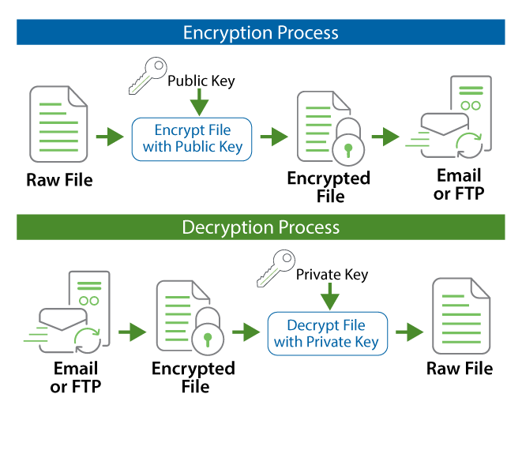
The process is illustrated above.
Download Kleopatra from the following link: https://www.gpg4win.org/thanks-for-download.html

The process is also completed on the below Link:
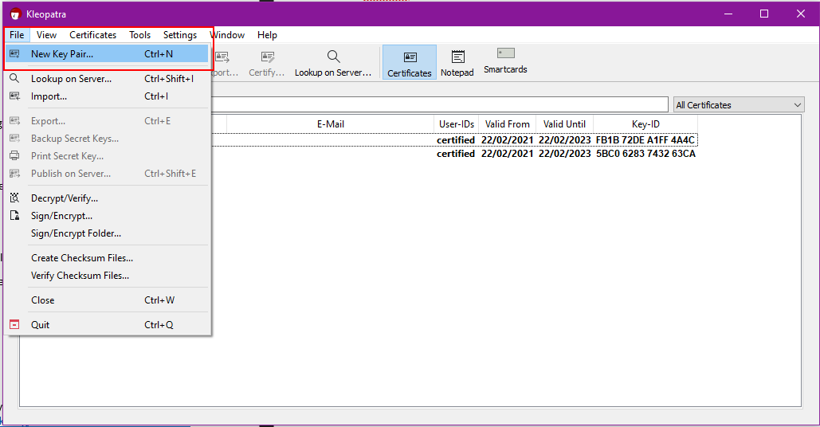

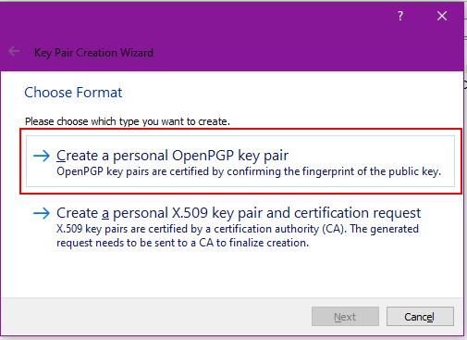

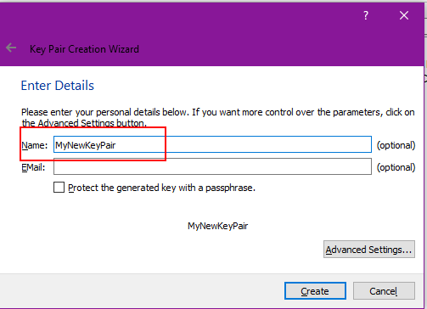
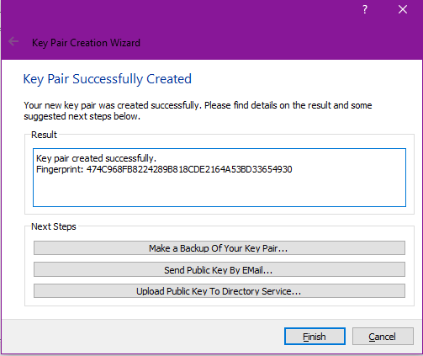
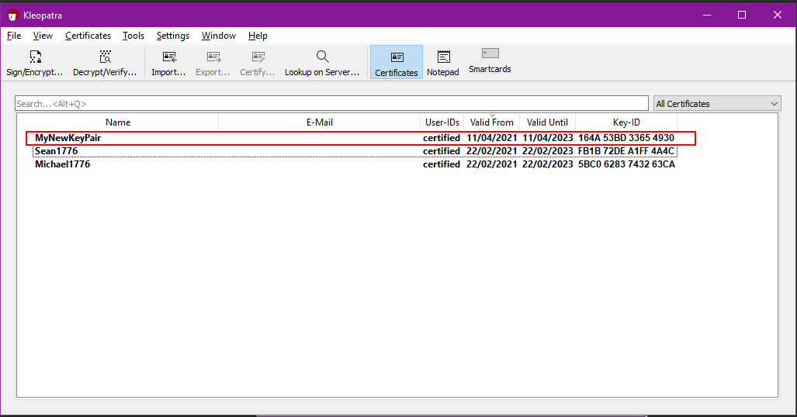

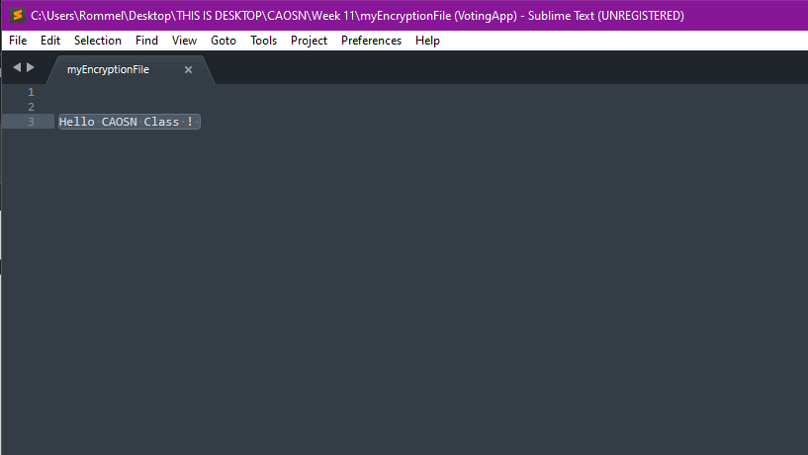

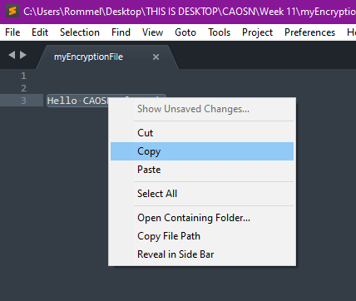
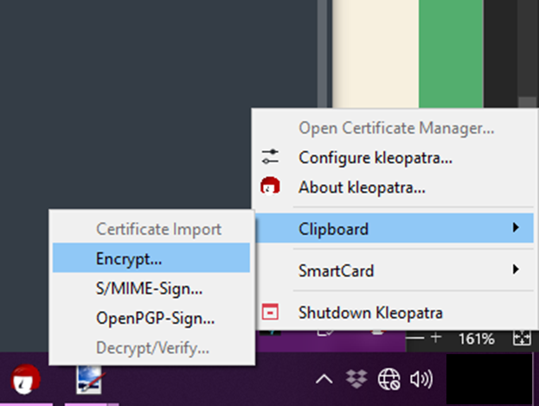

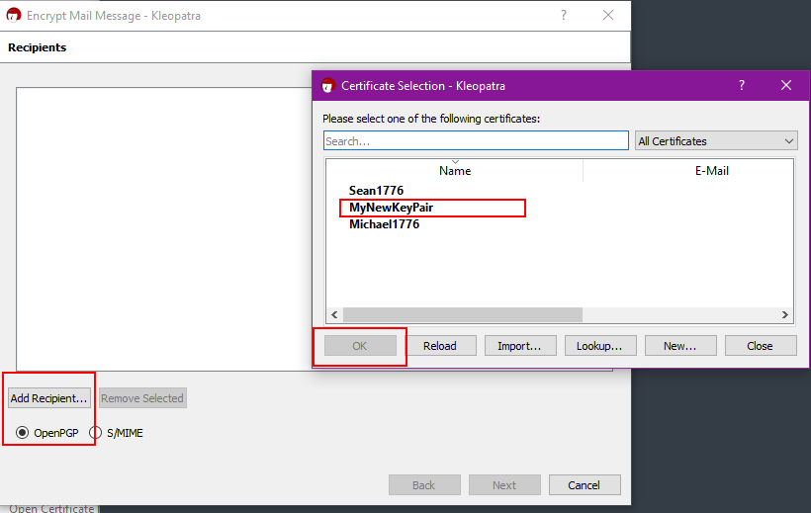
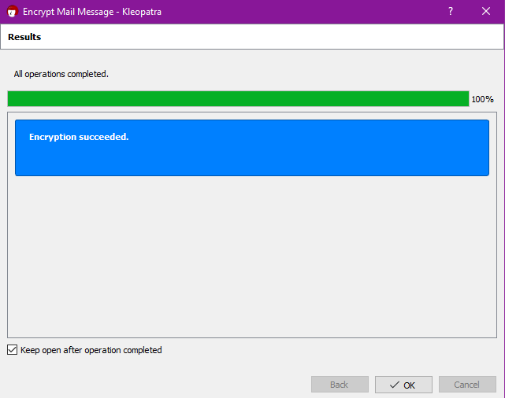

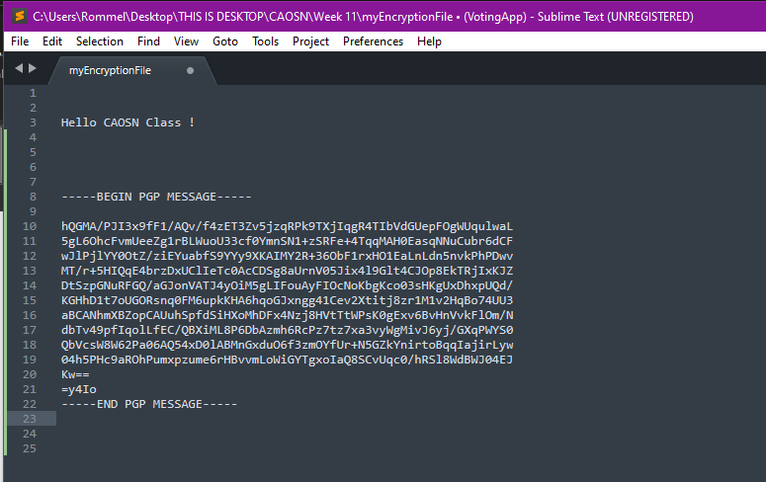

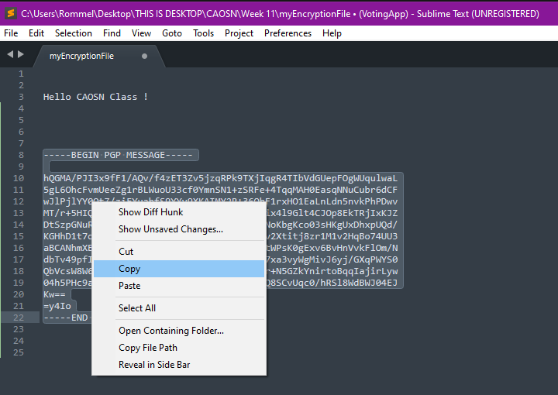
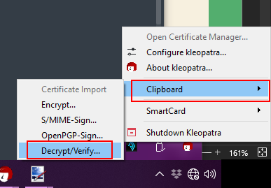
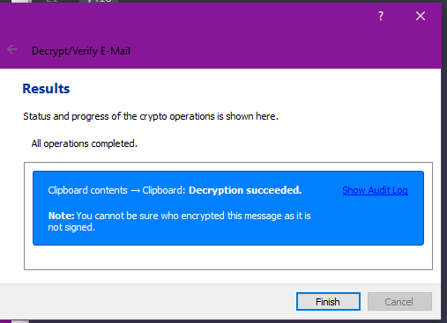
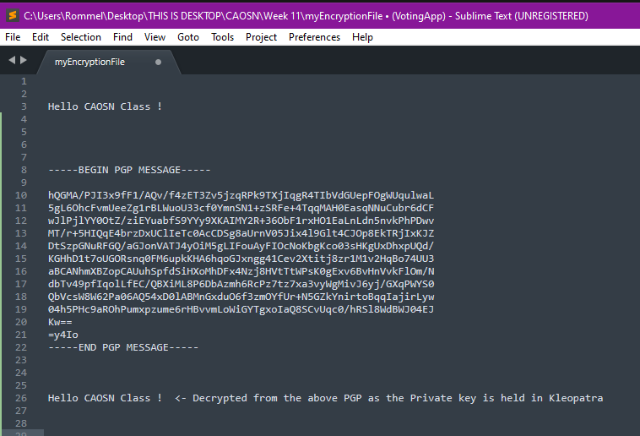

If you want to export and share your public PGP
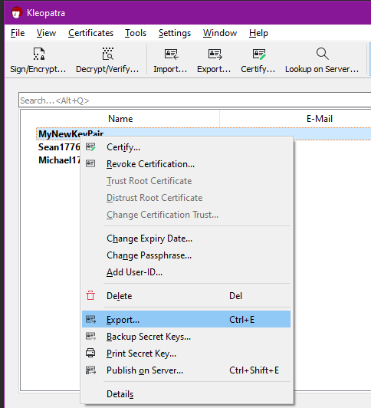
Save to your machine
Open to view and copy in text editor e.g Sublime / Notepad++
https://www.sublimetext.com/ https://notepad-plus-plus.org/downloads/
Once opened you should see something like the below:
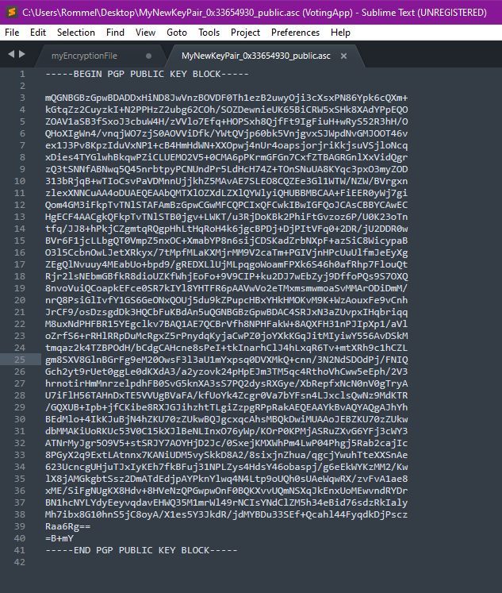
You can then share this public key for others to use to send you messages. Others would encrypt the message with your public key as shown here and only you being the holder of the private key can decrypt.

Example:
-----BEGIN PGP PUBLIC KEY BLOCK-----

mQGNBGBzGpwBDADDxHiND8JwVnzBOVDF0Th1ezB2uwyOji3cXsxPN86Ypk6cQXm+
kGtqZz2CuyzkI+N2PPHzZ2ubg62COh/SOZDewnieUK65BiCRW5xSHk8XAdYPpEQO
ZOAV1aSB3fSxoJ3cbuW4H/zVVlo7Efq+HOPSxh8QjfFt9IgFiuH+wRyS52R3hH/O
QHoXIgWn4/vnqjWO7zjS0AOVViDfk/YWtQVjp60bk5VnjgvxSJWpdNvGMJOOT46v
ex1J3Pv8KpzIduVxNP1+cB4HmHdWN+XXOpwj4nUr4oapsjorjriKkjsuVSjloNcq
xDies4TYGlwhBkqwPZiCLUEMO2V5+0CMA6pPKrmGFGn7CxfZTBAGRGnlXxVidQgr
zQ3tSNNfABNwq5Q45nrbtpyPCNUndPr5LdHcH74Z+TOnSNuUA8KYqc3pxO3myZOD
313bRjqB+wTIoCsvPaVDMnnUjjkhZ5MAvAE7SLEO8CQZEe3Gl1WTW/NZW/BVrgxn
zlexXNNCuAA4oDUAEQEAAbQMTXlOZXdLZXlQYWlyiQHUBBMBCAA+FiEER0yWj7gi
Qom4GM3iFkpTvTNlSTAFAmBzGpwCGwMFCQPCIxQFCwkIBwIGFQoJCAsCBBYCAwEC
HgECF4AACgkQFkpTvTNlSTB0jgv+LWKT/u3RjDoKBk2PhiFtGvzoz6P/U0K23oTn
tfq/JJ8+hPkjCZgmtqRQgpHhLtHqRoH4k6jgcBPDj+DjPItVFq0+2DR/jU2DDR0w
BVr6F1jcLLbgQT0VmpZ5nxOC+XmabYP8n6sijCDSKadZrbNXpF+azSiC8WicypaB
O3l5CcbnOwLJetXRkyx/7tMpfMLaKXMjrMM9V2caTm+PGIVjnHPcUuUlfmJeEyXg
ZEgQlNvuuy4MEabUo+bpd9/gREDXLlUjMLpqgoWoamFPXk6S46h0afRhp7FlouQt
Rjr2lsNEbmGBfkR8dioUZKfWhjEoFo+9V9CIP+ku2DJ7wEbZyj9DffoPQs9S7OXQ
8nvoVuiQCoapkEFce0SR7kIYl8YHTFR6pAAVwVo2eTMxmsmwmoaSvMMArODiDmM/
nrQ8PsiGlIvfY1GS6GeONxQOUj5du9kZPupcHBxYHkHMOKvM9K+WzAouxFe9vCnh
JrCF9/osDzsgdDk3HQCbFuKBdAn5uQGNBGBzGpwBDAC4SRJxN3aZUvpxIHqbriqq
M8uxNdPHFBR15YEgclkv7BAQ1AE7QCBrVfh8NPHFakW+8AQXFH31nPJIpXp1/aVl
oZrfS6+rRHlRRpDuMcRgxZ5rPnydqKyjaCwPZ0joYXkKGqJitMIyiwY556AvDSkM
tmqaz2k4TZBPOdH/bCdgCAHcne8sPeI+tkInarhClJ4hLxqR6Tv+mtXRh9c1hCZL
gm8SXV8GlnBGrFg9eM20OwsF3l3aU1mYxpsq0DVXMkQ+cnn/3N2NdSDOdPj/FNIQ
Gch2yt9rUet0ggLe0dKXdA3/a2yzovk24pHpEJm3TM5qc4RthoVhCww5eEph/2V3
hrnotirHmMnrzelpdhFB0SvG5knXA3sS7PQ2dysRXGye/XbRepfxNcN0nV0gTryA
U7iFlH56TAHnDxTE5VVUgBVaFA/kfUoYk4Zcgr0Va7bYFsn4LJxclsQwNz9MdKTR
/GQXUB+Ipb+jfCKibe8RXJGJihzhtTLgiZzpgRPpRakAEQEAAYkBvAQYAQgAJhYh
BEdMlo+4IkKJuBjN4hZKU70zZUkwBQJgcxqcAhsMBQkDwiMUAAoJEBZKU70zZUkw
dbMMAKiUoRKUc53V0C15kXJlBeNLInxO76yWp/KOrP0KPMjASRuZXvG6YFj3cWY3
ATNrMyJgr5O9V5+stSRJY7AOYHjD2Jc/0SxejKMXWhPm4LwP04Phgj5Rab2cajIc
8PGyX2q9ExtLAtnnx7KANiUDM5vySkkD8A2/8sixjnZhua/qgcjYwuhTteXXSnAe
623UcncgUHjuTJxIyKEh7fkBFuj31NPLZys4HdsY46obaspj/g6eEkWYKzMM2/Kw
lX8jAMGkgbtSsz2DmATdEdjpAYPknYlwq4N4Ltp9oUQh0sUAeWqwRX/zvFvA1ae8
xME/SiFgNUgKX8Hdv+8HVeNzQPGwpwOnF0BQKXvvUQmNSXqJkEnxUoMEwvndRYDr
BN1hcNYLYdyEeyvqdavEHWQ35M1mrWl49rNCIsYNdClZM5h34eBid76sdzRkIaly
Mh7ibx8G10hnS5jC8oyA/X1es5Y3JkdR/jdMYBDu33SEf+Qcahl44FyqdkDjPscz
Raa6Rg==
=B+mY
-----END PGP PUBLIC KEY BLOCK-----

